Task A:

* Startup

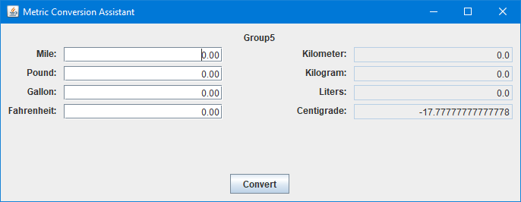

* Constant Declaration

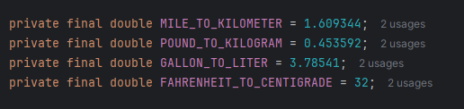

* Conversion Value

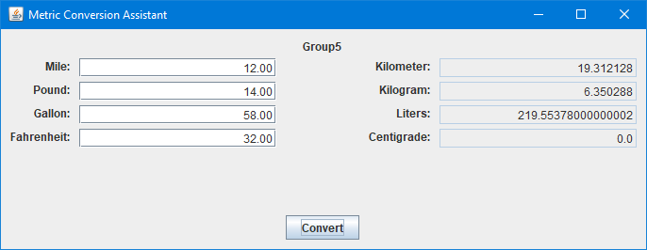

* Exception Handler

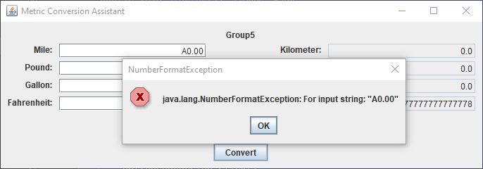

Tack B:

* Startup

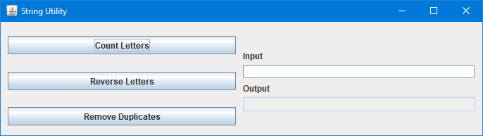

* Count Letters

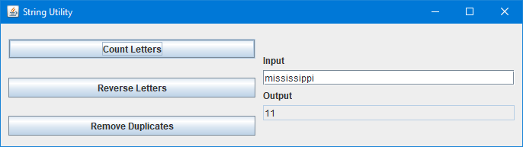

* Reverse Letters

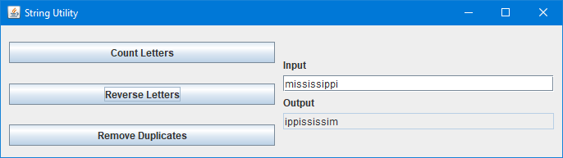

* Remove Duplicates

